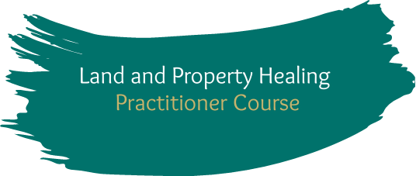

Participant Intake Form
Name:
Address:
Email:
Phone:
Course date and location: Gold Coast, August 8-12, 2022
Questions to complete:
- What outcomes would you like to achieve from the Land and Property Practitioner Course?

- Have you had any previous experience working with energy healing?

- Would you consider yourself someone who has have an affinity for nature?

- Do you work in property development or real estate?

- Do you have any dietary requirements?

- Do you have any health concerns which could affect your ability to complete the course?

- Are you over 18? If not, parental/guardian consent required below
Name of parent/guardian:
Signature (typed name is fine):

Please send completed form to: mahdi@drmahdimason.com

